Project 2

ID：0811562 name：何祁恩

(a)code

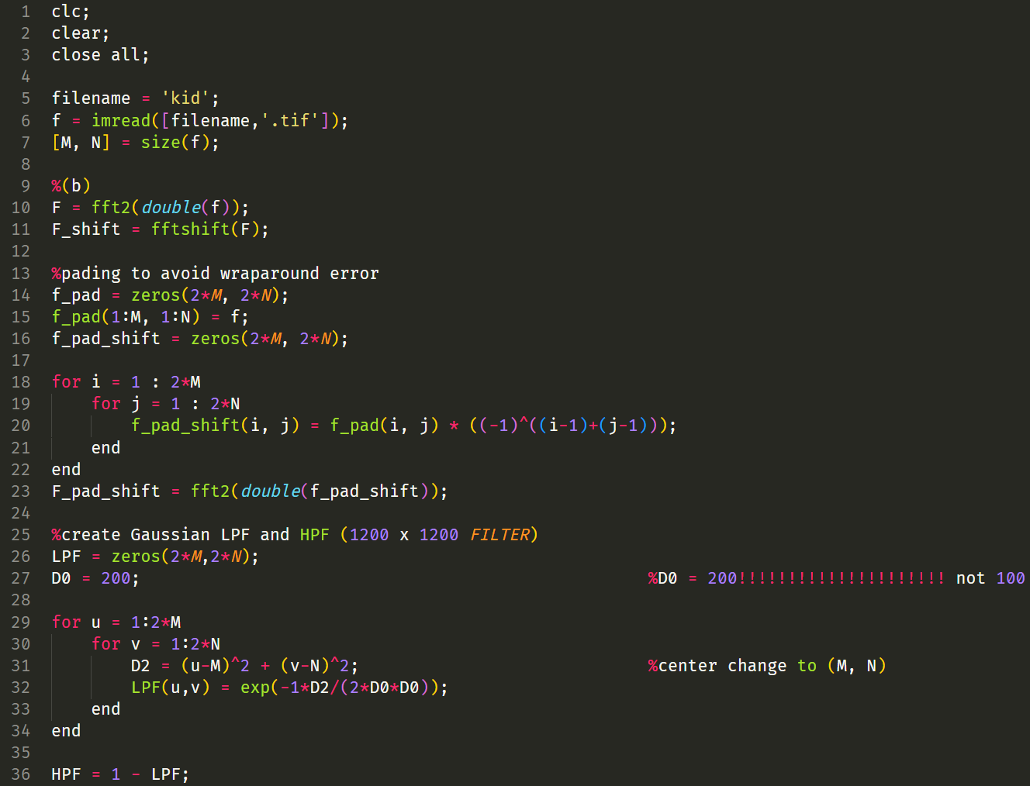

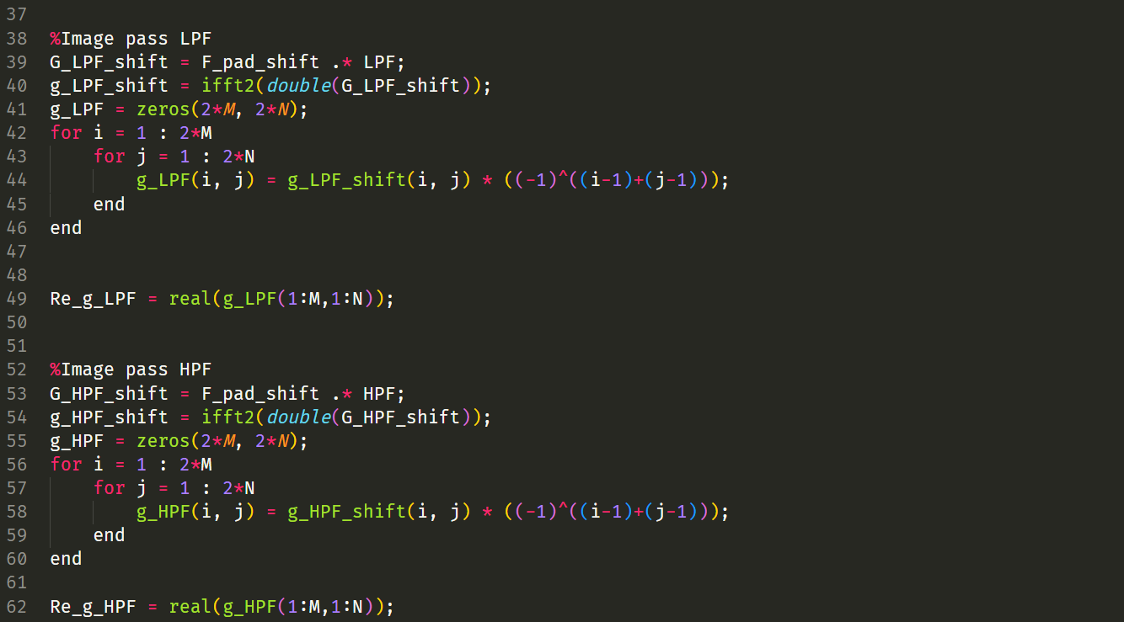

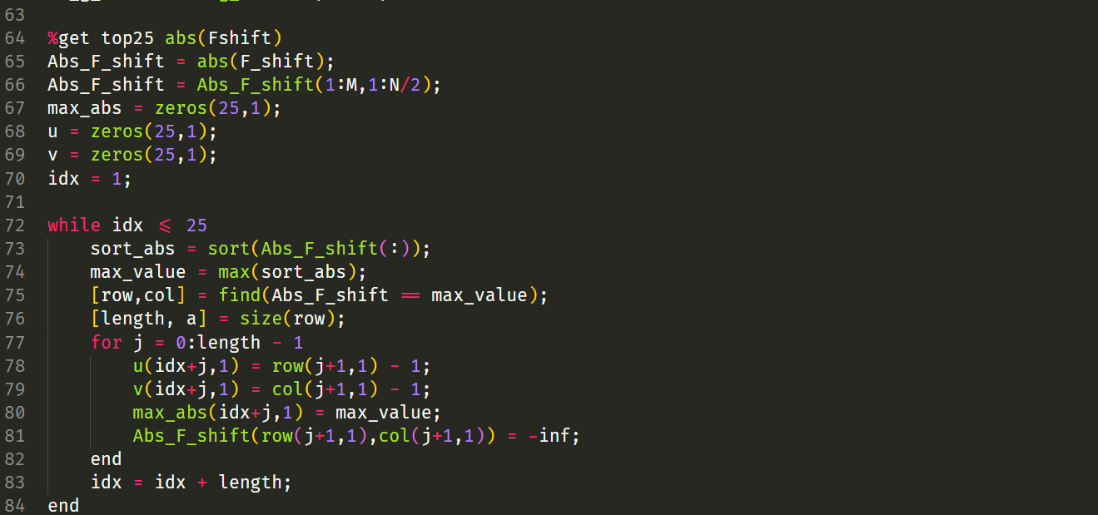

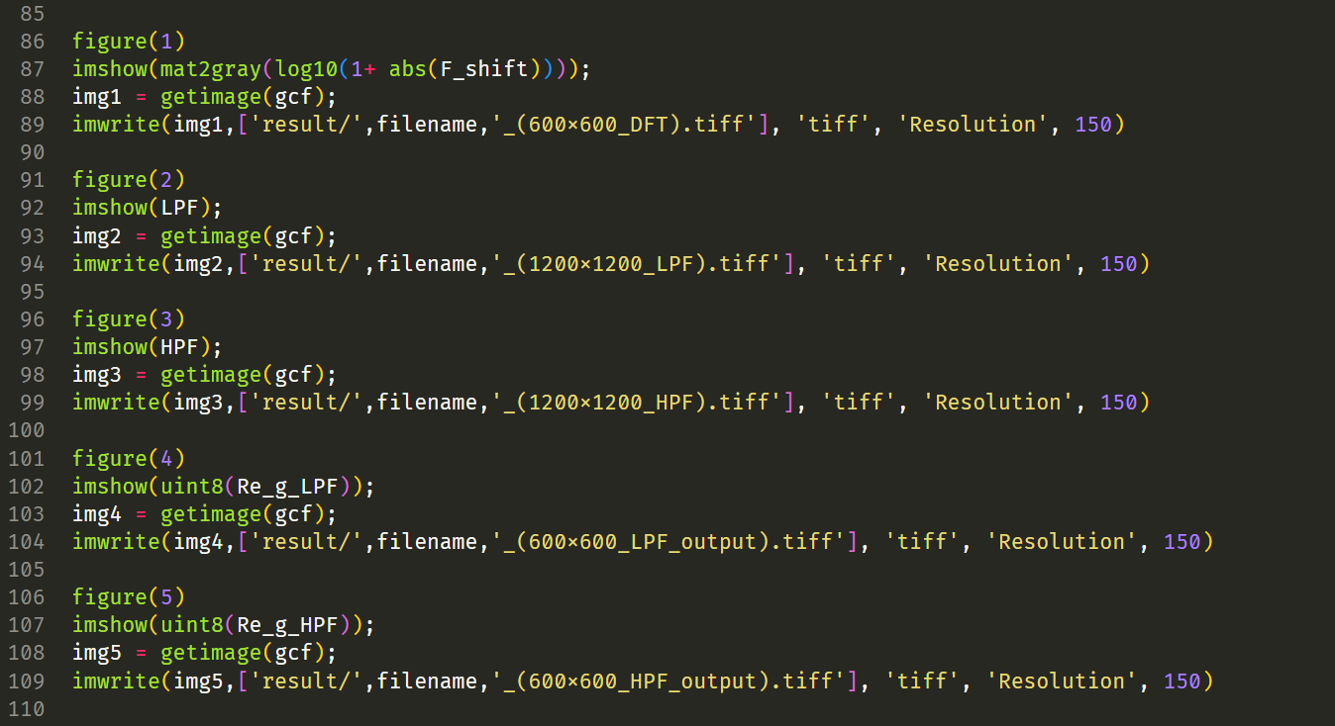

(b) Fourier magnitude spectra (in Log scale) of kid and fruit (600x600 DFT)

|  |  |
| --- | --- |
| kid | fruit |

(c) Magnitude responses of Gaussian LPF and HPF D0 = 200! Not 100!!!!!!!!!!!

D0 = 100 pixels based on the original image size (600 * 600), but we perform a gaussian filter on (1200 * 1200) to avoid wraparound error, so we should choose D0' by calculating :

(100^2 * pi) / 600^2 = ((D0')^2 * pi) / 1200^2 -> D0' = 200 pixels for expanding the image to double size

|  |  |
| --- | --- |
| LPF (1200x1200) | HPF (1200 x 1200) |

(d) 4 output images

Kid LPF, HPF

|  |  |
| --- | --- |
|  |  |

Fruit LPF, HPF

|  |  |
| --- | --- |
|  |  |

The output image from HPF is so black, but we still can see some edges detected.

(e) start from left top

Kid in descending order: Fruit in descending order

|  |  |
| --- | --- |
| u | v |
| 301 | 299 |
| 300 | 299 |
| 299 | 299 |
| 298 | 299 |
| 297 | 299 |
| 299 | 297 |
| 302 | 298 |
| 298 | 298 |
| 298 | 294 |
| 302 | 299 |
| 302 | 296 |
| 299 | 298 |
| 304 | 298 |
| 316 | 298 |
| 299 | 294 |
| 301 | 296 |
| 317 | 298 |
| 296 | 296 |
| 296 | 298 |
| 316 | 297 |
| 300 | 294 |
| 298 | 292 |
| 297 | 296 |
| 298 | 297 |
| 301 | 297 |

|  |  |
| --- | --- |
| u | v |
| 300 | 299 |
| 301 | 297 |
| 300 | 298 |
| 296 | 299 |
| 303 | 297 |
| 300 | 297 |
| 299 | 299 |
| 295 | 299 |
| 302 | 297 |
| 297 | 298 |
| 301 | 294 |
| 298 | 299 |
| 300 | 295 |
| 302 | 299 |
| 304 | 299 |
| 303 | 299 |
| 296 | 294 |
| 299 | 298 |
| 303 | 298 |
| 299 | 296 |
| 296 | 296 |
| 306 | 299 |
| 297 | 296 |
| 299 | 297 |
| 302 | 295 |

Feedback:

I think I didn’t do anything wrong in this project, I follow the PPT process given in class. However, I think the given D0 is not so good to observe the output image after Gaussian LPF and HPF. I do check the definition of 2D DFT taught in class has the same formula as Matlab implementation:

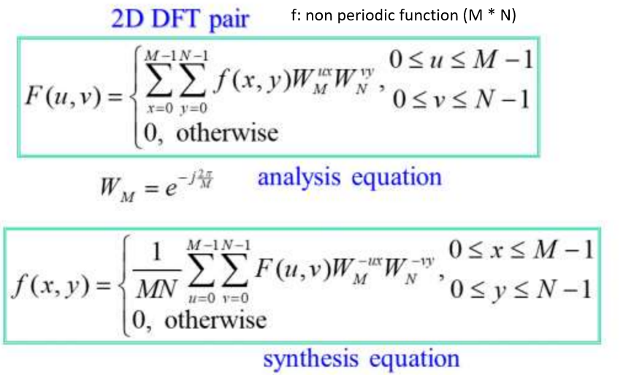

Matlab implementation of 2D DFT:

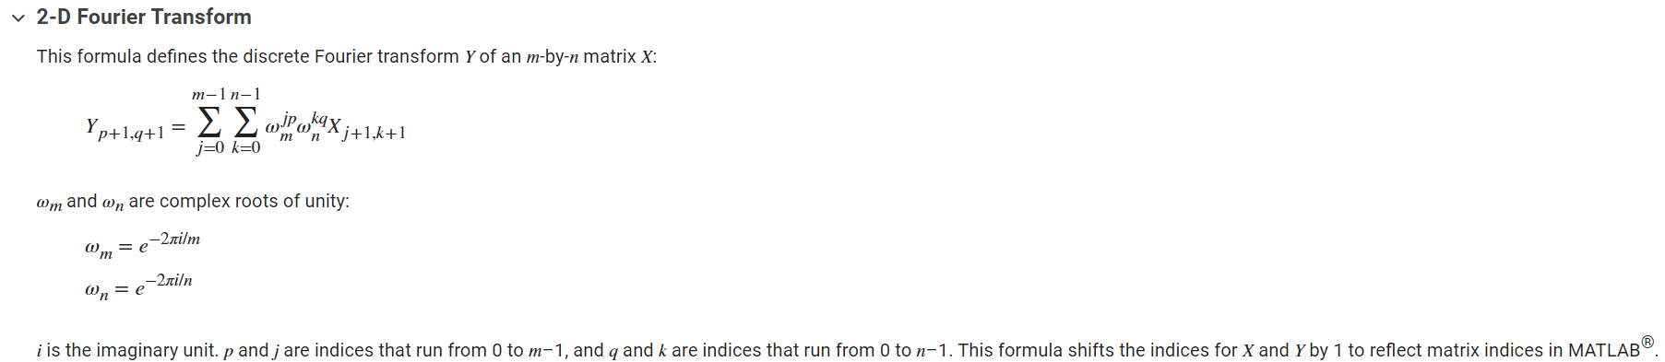

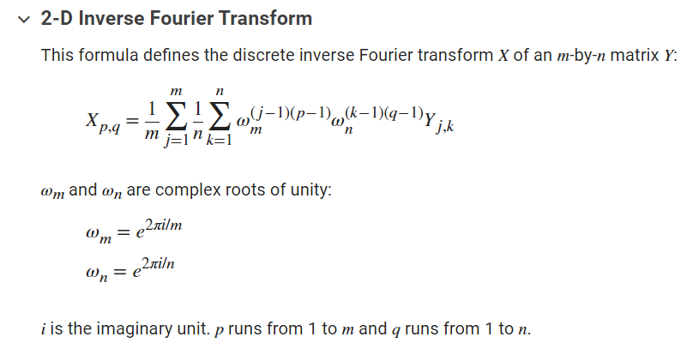

In python, fft provided by NumPy seems to have a normalized coefficient different from the formula given above. Therefore, I choose Matlab to do this project.

Some other results (without any post-processing):

For Do = 100

Fruit LPF, HPF:

|  |  |
| --- | --- |
|  |  |

KID LPF, HPF:

|  |  |
| --- | --- |
|  |  |

The output result of LPF becomes a little blurry, and the output result of HPF becomes clear.

For D0 = 50

Fruit LPF, HPF:

|  |  |
| --- | --- |
|  |  |

KID LPF, HPF:

|  |  |
| --- | --- |
|  |  |

When D0 = 50, the output image from LPF becomes very blurry, and the output image from HPF detects more edges clearly. I think the difference between us might be the implementation detail under those package functions.

It is quite fun on this project, and I learn a lot!